41.7: a)
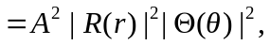 which is independent of
b) 